
Organisers Handbook
Introduction
Please note that the latest revisions to this document are shown in italics.

This handbook is intended to help regular and prospective organisers to plan and execute a successful event. It will not be an exhaustive manual for running an event but it pulls together information from various sources to help to plan your event.
British Cycling have an event organising and resources section on their website:
https://www.britishcycling.org.uk/dashboard/article/20141202-Cyclo-cross-event-documentation---resources-0
Please also familiarise yourselves with the Wessex rules:
https://www.wessexcyclocross.co.uk/league-rules/
The members of the Wessex Committee have many years combined experience of organising League, National and UCI level events and are happy to help anyone who wants to put on an event – please ask!
If you have any feedback or suggestions to improve the manual please let us know at info@wessexcyclocross.co.uk
The main topics covered are:
- Event organising team
- Budget
- Venue
- Design and prepare the CX course.
- Event facilities
- Marshals
- Entries
- On the day
- Post event

- Event organising team
Having a team to help organise and run the event is essential for any club/voluntarily run event. Recruiting team leaders to cover different aspects of the event will help, e.g:
Overall Event Lead
Marshal Lead
Course Build/Takedown
Sign-On Lead
Etc.

Smaller clubs can (and often do) collaborate to organise an event to ensure there are enough volunteers and spread any financial risk.

2. Budget
Wessex CX events generally break even or make a small profit. Often events are run for the benefit of the organizing club to allow then to run less profitable races.
Costs to consider include: Venue hire, Timing, Prizes, Commissaire costs, Levies, Course equipment (if not using Wessex/club equipment), Toilet hire, Medical Cover, Radio hire.
Medical Cover is provided at a fixed cost for each Wessex event by Collingwood Services Ltd. Eventrex have a contract with a toilet hire company that may offer better rates so worth checking with them.

Organisers often raise money from sponsorship to help offset costs. The Wessex League also have funds available to help if an event is struggling to meet its costs.
BC have created a budget template that may help:
https://www.britishcycling.org.uk/zuvvi/media/bc_files/officials/Event_budget_template.xls

3. Venue
Booking a venue for an off-road event may feel like a difficult task. This guide has been written to help event organisers with the process of booking and retaining it for future use.
• Find a venue that you would like to use for your event, identify the venue owner and register your interest with them (most public venues will have a website with contact details to allow you to send your enquiry).
• Arrange a meeting at the venue to discuss your ideas for the event and the areas you would like to use (it is good to have a rough idea of which areas you would like to use for the event before attending the meeting). If you are uncertain about how to approach the meeting ask a Wessex CX Committee member for help!
When you meet with the landowner to discuss your event it is useful to walk through the proposed course together. This will enable you to identify any areas of the site to be avoided and discuss the landowner’s expectations – particularly in terms of previous events that may have been delivered. This negotiation and planning process is best done on-site. The meeting should give you the following information:
- Dates the venue is available.
- Cost of hire.
- Site plan with the areas that you are allowed to use.
- Other activities taking place at the venue?
- Are there any other local events that may affect your event? For example, a car boot sale, equestrian event, funfair or fête?
- Facilities that are available for use by the event e.g. Toilets, showers, café.
- Rider and spectator parking – Wessex events may have 300 cars on site at any one time.
- Access arrangements before and after the event (consider setup and breakdown). Does the course building activity require risk assessing, insurance or supervision? British cycling event insurance does not cover pre-event activities.
- Can the course, paths, and arena area be cleared of overgrowth/mowed before the event? Depending on the time of year, any grassed areas of your course could change significantly in the period between meeting the landowner and the event date and could require mowing in advance of your event.
- Are you restricted to using the existing tracks or is there scope to introduce new track sections or features on the site?
- What type of course marking will be allowed or required at the venue? For example, is spray paint acceptable for the finish line or to identify natural obstacles on the course?
- Any costs that will be incurred for venue damage or opportunity to repair any damage.
- Booking form.
- Emergency Vehicle access points on site.
- Can you bring vehicles onto the field of play, i.e. timing company vehicles, to assist in building the course, or for dropping off equipment?
- Is it possible to bring catering onto the site?
- Is jet washing is permitted on the site?
- Risk assessments and insurance cover required.
Are there any public rights of way? Actions below:
  - Public Footpath: To use a Public Footpath for a CX race you need to get the landowner and the local authority to approve a diversion. There is usually a footpath diversion form available on the local authority website
  - Bridleway: These are very difficult to include in a race. Through riding on one is legal, it is illegal to race on one. The only way to get authorisation for this is with approval from a Secretary of State – there are probably easier battles...
  - Byway: These are suitable for racing on. You will need to get approval from the Chief Commissaire for your event and engage with the Accredited Marshal Coordinator for your region as a Byway is considered similarly to a Highway, because it can have motor vehicles on it. You will also need to get support/approval from the Local Authority & Landowner
- Are there any noise restrictions on the site that the event commentator needs to be aware of?
- Submit booking form (along with supporting documents).
Information required by the venue.
Some venues will require specific information that they will request to complete the booking.
Be prepared to provide the following as a minimum:
• Venue specific booking form.
• Venue plan, mapping the route/course.
• Risk assessment.
• Insurance indemnity form (from British Cycling) – this is available after registration with BC & submission of risk assessment.
Tips for retaining a venue.
Many venues are supportive of making an event annual at their venues. It is important to manage relations with a venue manager/owner correctly to be welcomed back year on year. Several things can be done to ensure that your event has the best opportunity to use the same venue in the future.
Ensure the venue is aware of the possible impact.
This could alter the areas the venue would like you to use but also avoids the possibility of the venue charging for any damage caused to the venue.
Meet with the venue management before the event.
Not only will this help maintain good relations with the venue management it will also highlight any issues that may have occurred before the event takes place. As an organiser, you don’t want to arrive at the venue to find that you are not allowed to use a particular area for the event.
Arrange a review meeting after the event.
This allows you to discuss what the venue management thoughts were on the event. This will give you a better perspective of the possibilities at the venue in the future.
Plan early for the following year.
If everything has gone well, the venue is happy with how the previous event has gone and you wish to use it again ask for provisional dates as early as possible. Venues like to be well organised when hosting events so the earlier you can get a date in the calendar the better for both parties.

4. Design and prepare the CX course.
To keep cyclo-cross courses engaging and attractive to riders, event organisers are encouraged to be creative with the design of their course, whilst keeping it appropriate for the level of competition and within the regulations. Examples could include:
• Incorporating natural features or unique venue features which make the course distinctive to that location, or
• Develop a personal design style or characteristic which could be associated with a particular organiser or series.
When planning your course, you should aim to include the following features.
- A lap between 2.5 and 3.5 km in length, of which 90% should be rideable.
- A start area that will allow for the gridding of riders with call up area where riders line up in herringbone formation. A start line that can cater for an 8 wide rider grid with enough straight to allow racing before any turns or funnels. Example from BC manual:

Figure 1 Start Example
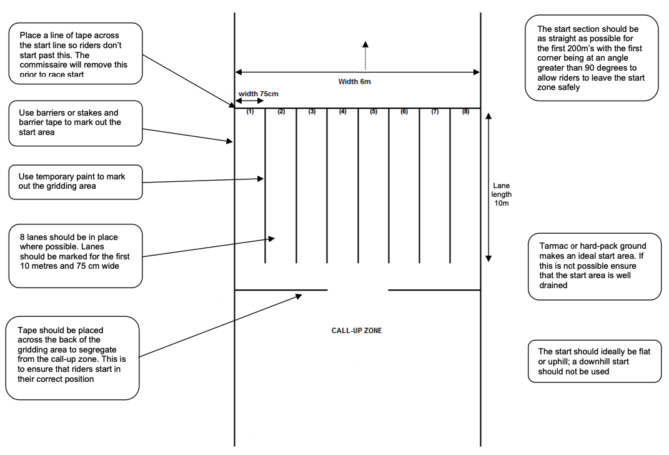
- A finish area with an adequate runoff for riders to slow down and space for timing gantry, gazebo and equipment.
- Straight and clearly defined pit areas. Pit area should allow for entry from 2 parts of the course. Overall length of the pit area should be around 30-40 meters.
Some thought should be given to the location of equipment pits, where riders can change bikes or equipment. This needs plenty of space for riders and helpers on the right-hand side of the course. The zone should ideally be flat and should not offer an advantage to those using this route rather than proceeding via the main course. If it is muddy, helpers are likely to arrive equipped with jet washers, so an area suitable for bike cleaning should be identified which minimises run-off onto the course or into public areas.

Figure 2 Pit Example
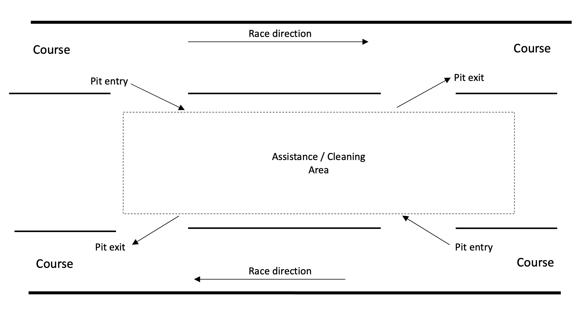
- There should be no pit provision for Under-12 races.
- No more than 6 man-made obstacles (a part of the course where the rider is required to dismount). Obstacles must be less than 80m in length (for example sandpits) and less than 40cm in height (planks/hurdles), which must span the full width of the course.
- Country and forest paths, roads and meadowland that are well marked and a minimum of 3m wide to allow for safe overtaking.
- If you are required and permitted to clear overgrowth, always cut branches right back to the tree trunk with no protrusions, these could otherwise present a hazard to riders.
- Courses for riders U12’s and younger need to cater for all abilities and aim to encourage participation and fun. These races should be on a shorter course where riders are visible to officials at all times. This may utilise a section of the main circuit or be staged on a completely separate course.
- Organisers shall be encouraged and supported to include double barriers of between 200-250mm (spaced at 4m) high in youth U14 and U16 and adult races. A single barrier of between 50-100mm shall be the aim in U12 races, with none in the U10/U8 races. These planks should be positioned in flat area some advantage can be gained by hoping the planks.
- It is also important to consider access to the site for other users and how your course will impact them, planning alternative routes for walkers and other users where possible. Advance warning notices will be important to notify users of the event from around 2 weeks before the event taking place and on the day of the event. Appropriate signage and crossing point marshals will be needed to help re-direct anyone affected around the site.
- Over its full length, the course shall be well marked and protected and controlled by marshals as required.
- The use of harmful elements such as wires (barbed or not) and metal poles shall be forbidden, and the course shall not approach any object that could constitute a danger to riders.
- Steps may not be placed on downhill stretches
Courses shall not be directed through water where an alternative route avoiding it can be found.
- In a cyclo-cross race, it is not necessary to tape both sides of the entire course, as at times the trail will present an obvious route for riders to follow, however, the course should be taped and marshalled in areas where riders might take advantage of available shortcuts.
- Course tape: To avoid the tape being caught on the rides’ handlebars during the race, or blown across the course in the wind, it is best practice to keep the course tape lower down on the Course poles.
- In areas where there are steep or potentially hazardous downhill sections, courses must be marked with plastic posts, ski slalom gates, PVC piping, or similar, one to two meters high. Metal posts are inappropriate and not to be used.

Risk assessment with course map
A risk assessment needs to be done and uploaded to the event webpage on the British Cycling website. The risk assessment needs to be taken seriously because, without it, British Cycling will not provide public liability insurance and the event will not be able to go ahead. However, it is not necessary to go into too much detail. Basic mitigation is acceptable, such as positioning a marshal at a crossing point or making sure that helpers such as the sign-on team know what they are doing.
Organisers could contact one of the Wessex Committee who can access a similar risk assessment to use as a template. Otherwise, a blank risk assessment form is available to download from British Cycling.

Venue and site risk assessments
Event risk assessment should also include the general conditions that must be adhered to at the venue and any other risk-specific conditions. This can include but is not limited to the below.
- Event personnel.
- The car park.
- Toilets and changing rooms.
- Gazebo’s and other temporary structures.
- Course security.
- Adverse weather conditions.

Additional forms
Where required, specific risk assessment forms (from the local authority or forestry commission) will also need to be completed and returned.

Figure 3 Example Courses
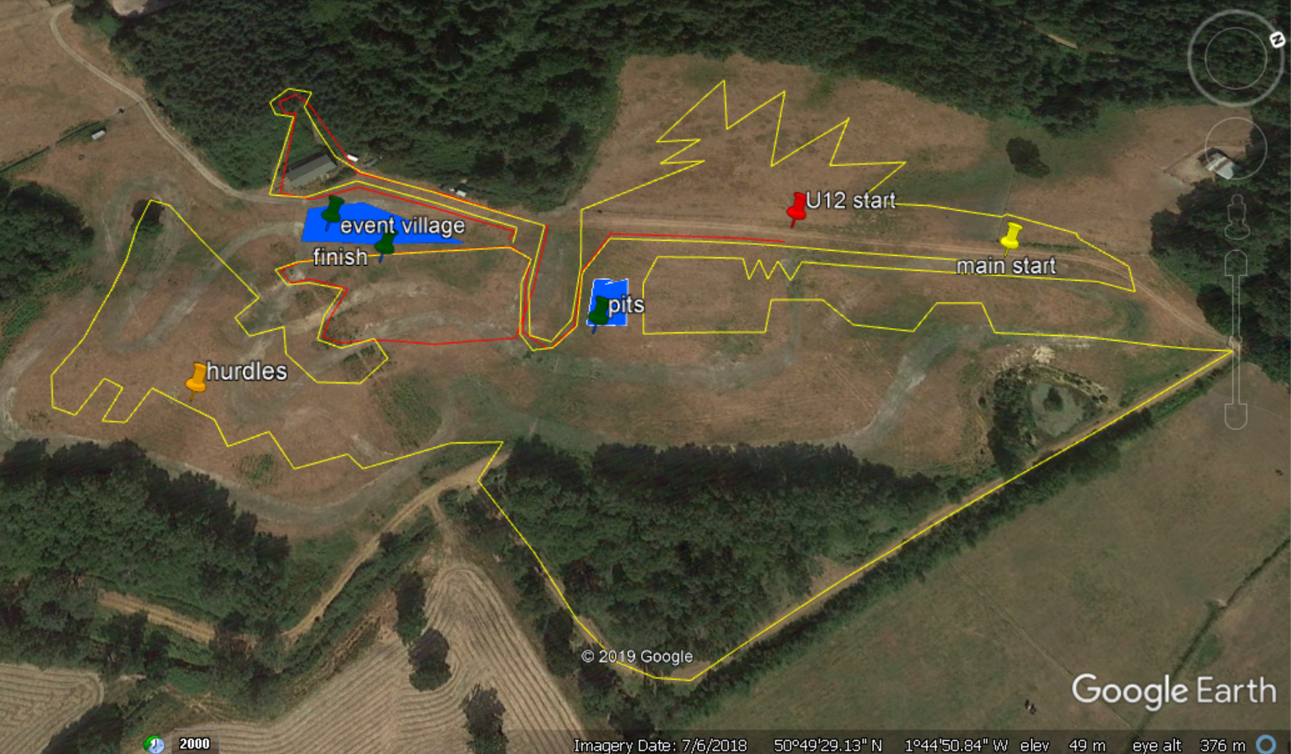

Figure 4. Credit Ian Perryman/Clanfield Cross
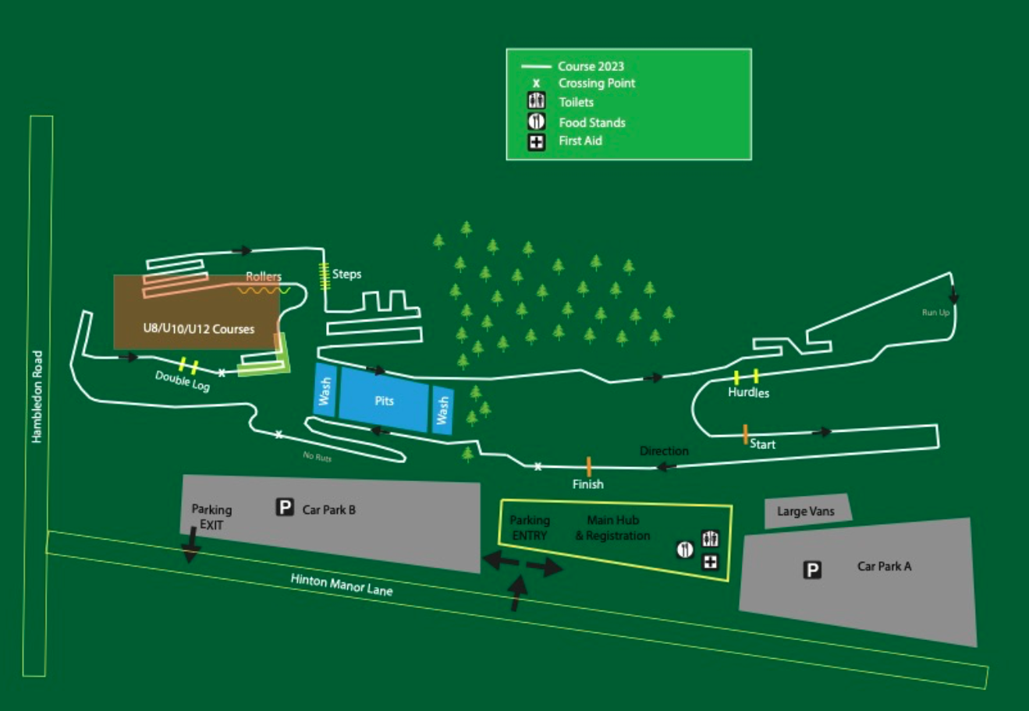

5. Event Facilities

Event Flags
The Wessex League have a set of feather flags available to help riders and spectators to find their way around the venue. These include Sign-On, Start, Finish, Pits and First Aid. Using these flags adds a level of consistency to the League events. These flags will be supplied by the Wessex League but it is the responsibility of the race organiser to arrange for these to be assembled and distributed at the start of the event and disassembled an packed away at the end of the event.
Toilets
Wessex CX events require a minimum of:
1 urinal block (4-6 urinals) and 4 cubicles with a minimum of 1 reserved for Women only. Large events should consider extra cubicles. If the venue has toilets available for use on the event ensure they are available throughout the duration of the event (including for people arriving early).
Toilet hire: Eventrex have a contract with a portable toilet hire company and can offer competitive rates. These would normally be delivered the day before a race and removed the day after.
Food/drink vendors to be encouraged to stay until the end of the final race (around 4pm)

First aid
The Wessex League have negotiated a deal with Collingwood Services Ltd to provide medical cover for all league events. This ensures that the correct level of cover is provided by staff with an appropriate level of experience. They must be on station by 8am on the day of the race. These First Aid Professionals can not have any other role in the race organisation on the day.
Also, consider casualty evacuation from more remote sites that may require emergency services, as well as helicopter access should the need arise. Please bear in mind that if the first aiders have to transport someone to hospital racing will be suspended until first aid cover is restored.

Organisers should have some local taxi numbers to hand in case of an injury occurring that requires non-emergency hospital attendance but they are unable to transport themselves.

Organiser equipment
The Wessex League has an equipment store located in Southampton that includes everything you should need for setting up a course. Equipment can also be hired from Eventrex based in Newbury.

Event day paperwork
Risk assessment forms and dynamic RA form
Event insurance certificate
Sign-on sheets for riders – printed with pre-entries and blank for entries on the day *
Bib numbers are supplied by the League *
Sign-on sheet for officials and volunteers
Course map for marshals and sign-on team
Copies of the race timings/schedule
Pens, pencils and paper pads.
Commissaire payments
* - Sign on Sheet creation and Bib number allocation is covered in separate documentation.

Signs
Caution Cycle Event signs
Venue signs; competitor car park, toilets, bike wash area etc.
The course
Direction and caution arrows
Course marking tape
Plastic poles
Course repair tools
Protective pads for any obstacles
Event arena
Event arena plan – including the location of team gazebo’s, trade gazebo’s, catering, toilets Power supply to catering if required
Marshals
Marshal bibs
2-way radios and headsets
Whistles
Flags
Race flags for marshals, course and finish line are supplied by the commissaires.
Sign-on area
Pens
Sellotape
Course map including start/finish area and event timings/schedule for sign-on desk
If not supplied by the Timing provider: Laptop and printer to produce updated start sheet for commissaires and timing team.
Screen for live timing/results.
Category prizes.

Event manual/technical guide
It is useful to also include these sections in a cyclo-cross event manual/technical guide.
- Facilities – cyclo-cross races take place in a variety of places including forests, parks and private land. They take in a variety of terrain and courses become known for the features they offer riders.
- Refreshments – this is useful information for riders, spectators, officials and commissaires.
- Car parking – so visitors know where to park and the distance from the course.
- Training – it is useful to know the times the course is available to riders for practice and time must be factored in for riders to pre-ride the course.
- Phone signal – if there is a signal on-site and if so which networks.

6. Marshalls

Marshal briefing will need to be given before the course opens – this can be done in advance of the event via online meeting or video. When assigning marshals to their station ensure they they are comfortable with that particular role. Rotating marshals to different roles/areas of the course throughout the day can help make the event more interesting for them and avoid being stuck in a dull location all day.
Marshals are often competitors who help out before/after their race.
BC have written some marshal guidelines:
https://www.britishcycling.org.uk/zuvvi/media/bc_files/officials/Off-road_marshal_guidelines.pdf

7. Event Registration and Entries
The Wessex League have set up a template for the BC website so all events will be consistent in their appearance. You will need to supply Adam Buckland with your British Cycling Membership Number and the full address for the venue, including postcode. Adam will then arrange for BC to place the template on your event organisers dashboard as a draft event. Once this has been done you will need to log into your dashboard and update the template with the following items:
- Event name, to be kept in the same format (Wessex Cyclocross League Round ##, Event Name or Promoting club)
- Event Date
- Check the Event Address
- Promoting Club and organiser details
- Safeguard Information
- Event Website and Social Links
- Event and Rider Info
- Payment Bank details to receive funds
- Entry fees
- Set online entry to close at 23:55 on the Tuesday before your event

Once all of these details have been updated you will be asked to submit your event for approval by BC and pay the registration fee which is currently £10.00

A Gridding list will be compiled by the Wessex League. The entry list it to be supplied to the Wessex League by 10am on the closing date of entries to allow time for gridding to be completed.

Creation of Wessex League sign on sheets is detailed in a separate document.
Refund policy: You will need to state a refund Policy e.g. –
If the event is cancelled the rider will get a full refund.
If the rider decides to withdraw from the event, at any stage, there will be no refund.

8. On the day
The course should be ready for inspection by the commissaires by 8am on the day of the race and will be open for practice once they have approved the course.

Medics should be in position by 8am and the course must not open until they are ready.
Riders must sign on before they can practice and must be wearing a timing chip so they can be identified.
Marshals briefing to be held before the course opens.
Commissaires will bring flags, lap boards and last lap bell.
The race timetable is:
Under 8 09.10
Under 10 09.35
Under 12 10.00
Youth 10.40 (U16 - 10.40, U14 - 10.41)
Open Junior, U23, Senior & Master 40 11.40
Women & Junior Women 13.10
Open Master 50 & 60 14.10 (Open 60 - 14.10, Open 50 - 14.12)

During course break-down any Wessex League equipment that it damaged must be notified to the League at the earliest opportunity – bear in mind that the next event could be the following week and may depend on that equipment.
Usable tape should be wound back on the holes reels and unusable tape should be disposed of – notifying the League of any shortfall.

9. Post event

Final Results are to be supplied to the League Points Secretary within 3 days of the event and also be submitted to British Cycling.
The Levy form and Levies to be submitted and paid to the League Treasurer within 2 weeks of the event. This can be found on the Wessex CX website under Event Organiser Resources.
Result queries should be handled in conjunction with the Timing supplier.

